LAB Assignment 2
Operating Systems (ULC-404)

1. Introduction of internal and external commands.
In UNIX, internal commands are built into the shell itself (like cd,echo) and execute directly without creating a new process, making them fast and efficient.
External commands are separate executable programs stored in system directories such as /bin.
When an external command (like ls,cat,) is executed, the shell creates a new process to run it.
Thus, internal commands depend on the shell, while external commands exist independently of it.
2. Feeding output of one command to another command by pipelining.
Pipelining in Linux uses the | operator to pass the output of one command as input to another.
It allows multiple commands to run together, processing data step by step without temporary files.
Only standard output is piped by default, making pipelines fast and memory-efficient.
Pipelining enables powerful command combinations for filtering, sorting, and analyzing data.
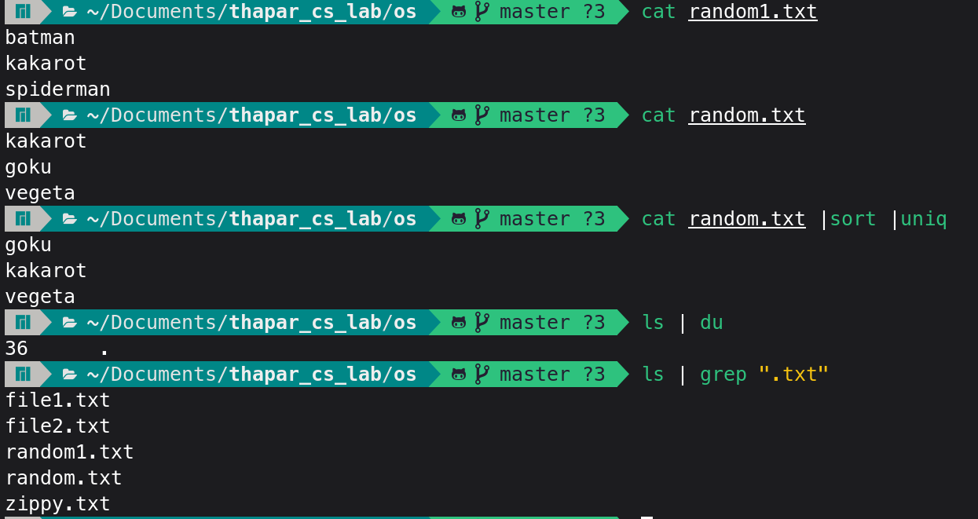

3. expr, locating command.
expr is used to evaluate arithmetic expressions, string operations, and comparisons in shell scripts.
It works with integers and returns the result directly to standard output.
locate is a command used to search for files by name using a prebuilt database.
It is very fast compared to find but may not show recently created files.
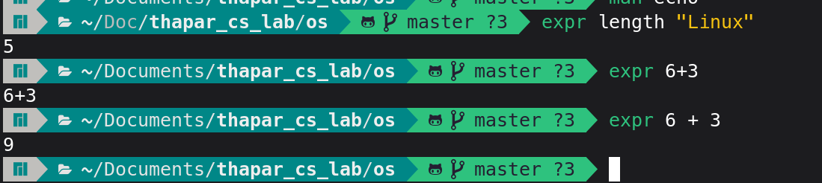
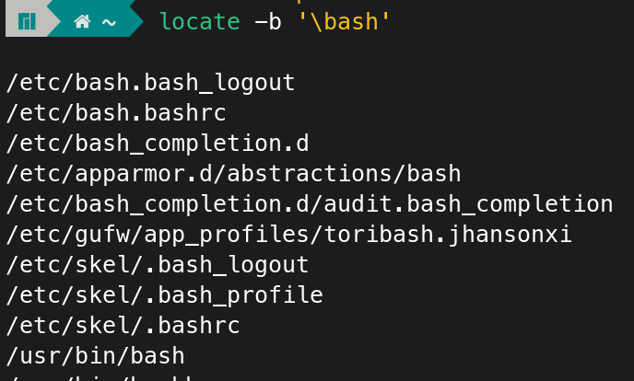
4. echo command.
The echo command in Linux is used to display text or variable values on the terminal.
It is often used in shell scripts to show messages or outputs.
Echo can print environment variable values by prefixing them with a dollar sign.
Its output can be redirected to a file using redirection operators.
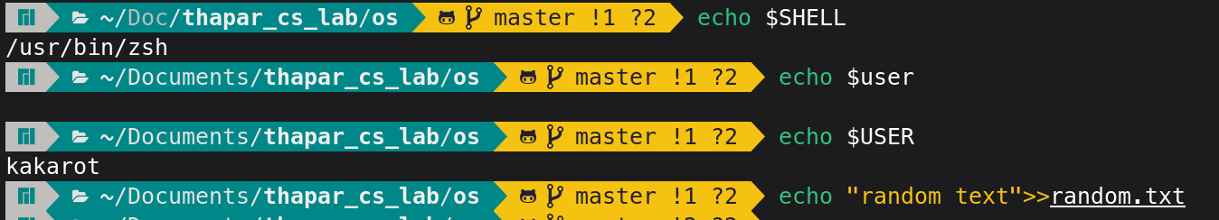

5.Using . and ..

In Linux, . represents the current directory, while .. represents the parent directory.
They are commonly used in navigation commands like cd . and cd ...
The . is also used to run scripts from the current directory.
Using .. helps move up one level in the directory hierarchy.
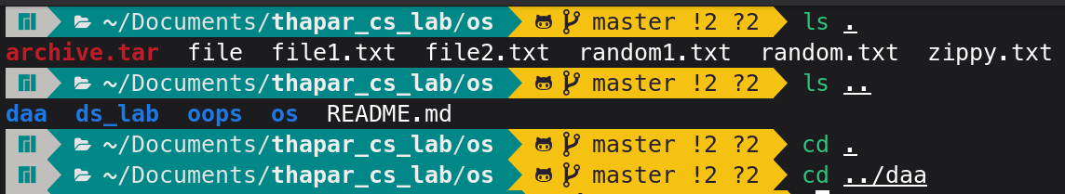

6. Ways for signing off from linux
Using the logout command in a terminal session.
Typing exit to close the current shell.
Pressing Ctrl + D to end the session.
Choosing log out or sign out from the desktop menu.


7) Ping, Man and help command.
Ping command is used to check network connectivity between your system and another host.
Man command displays the manual pages for Linux commands and utilities.
Help command shows brief information about shell built-in commands.
These commands are useful for troubleshooting and learning Linux commands.
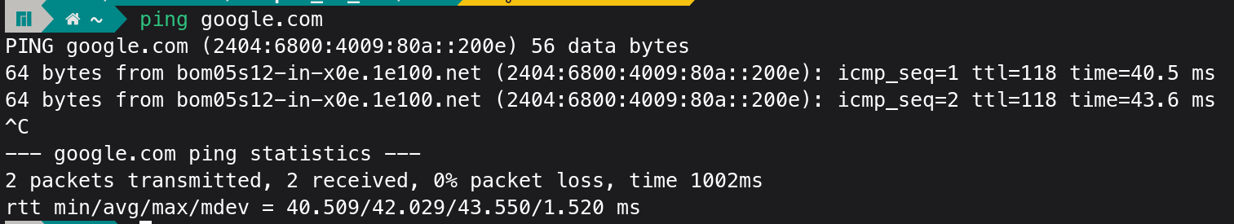
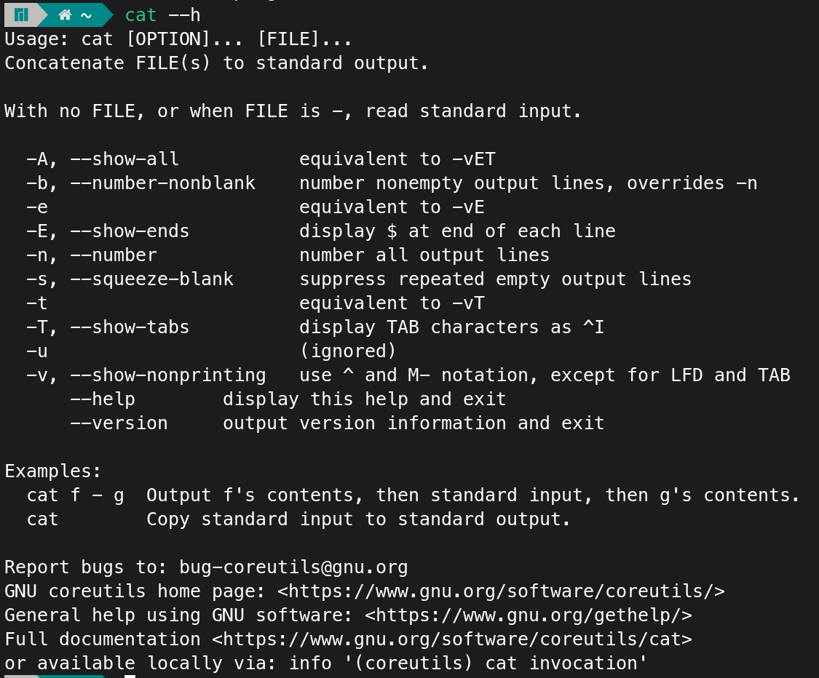

8.Combining the commands.
Combining commands in Linux allows you to use multiple commands together to perform tasks efficiently.
The pipe symbol | is used to send the output of one command as input to another.
Redirection operators like > and >> are used to send output to files.
Using combinations saves time and makes command execution more powerful.

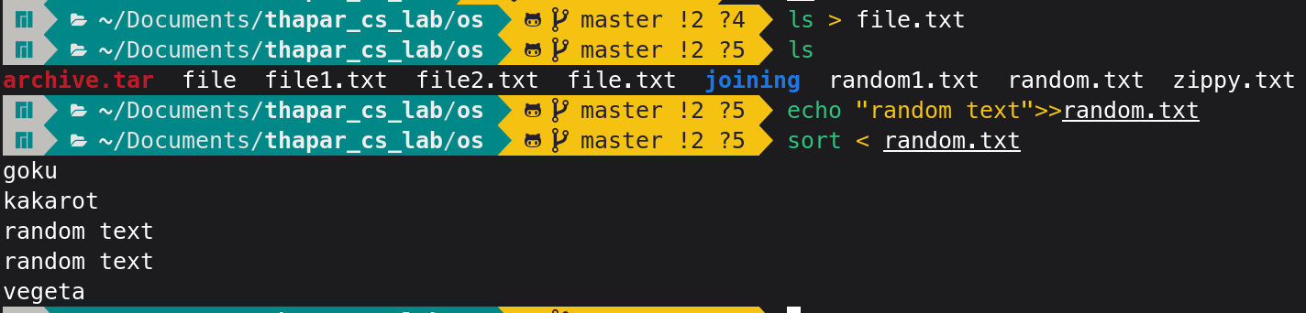
9 File permissions and changing the access rights (chmod)
File permissions in Linux control who can read, write, or execute a file.
Each file has permissions for the owner, group, and others, represented by r, w, and x.
The chmod command is used to change access rights using symbolic or numeric modes.
Managing permissions properly helps prevent unauthorized access and accidental modification.

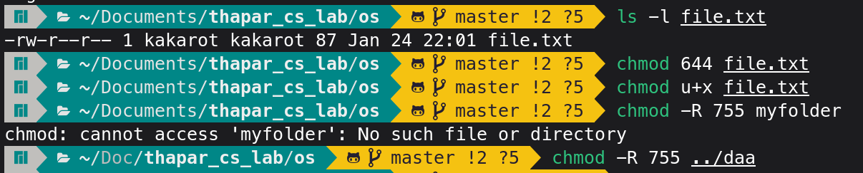

10 vi editor and its basics: write a small paragraph using vi editor.
The vi editor is a powerful text editor used in Linux for creating and modifying files.
It works in different modes, mainly command mode for navigation and insert mode for typing text.
To start editing, press i to enter insert mode, and press esc to return to command mode.
Files can be saved and exited using commands like :w,:q or wq

